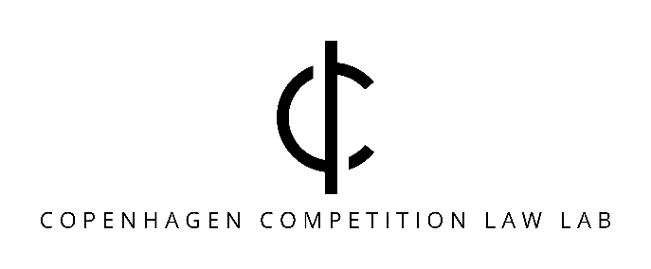

The More Economic Approach 20 years down the road. What went wrong?
Date: Monday, February 3, 2025
Time: 12.00 to 16.00.
Location: CBS, Room TBD.
Program:
12-00 – 13.15 | Welcome and introduction. | Christian Bergqvist, Associate Professor at Copenhagen University
12.15 – 13.00: | How did the economists end up in the driver’s seat?  How did we get to the Discussion Paper (2005) and the Enforcement Paper (2008)? Are the Draft Guidelines (2024) the revenge of the lawyers? | Svend Albæk, Visiting Fellow, European University Institute, and Senior Consultant, Charles River Associates; former Deputy Chief Economist, DG Competition, European Commission
13:00 – 13:45 | Putting the AEC test into work.  How did the More Economic Approach and the AEC test change how we review rebates? | Rie Paving Mortensen, Chief Economist, Partner at Plesner Law firm
13.45 – 14.00 | Break with coffee and cake.
14:00 – 14:45 | Blame it on the economist – Did the AEC make a difference?  Would cases such as Laurits Knudsen and Post Danmark I have ended differently without the More Economic Approach and the AEC test? | Peter Stig Jakobsen and Jesper Kaltoft, partners Bech Bruun Law firm
14:45- 15:30 | Full speed ahead.  Why does DG COMP want to replace the More Economic Approach and the AEC test, and how would that affect self-assessment? | Lars Kjølbye, partner Latham & Watkins LLP
15.30 – 16.00 | Questions and conclusion. | Kathrine Søs Jacobsen Cesko, Assistant Professor at Copenhagen Business School
Registration:
Register here to attend in person: seminar.jur@cbs.dk.
Registration deadline: January 27, 2025.
Link to attend online on Zoom: TBD
The event is hosted by CBS LAW and organized by Copenhagen Competition Law Lab, Christian Bergqvist and Kathrine Søs Jacobsen Cesko.

